4. **Event Streaming in EDA:**

Event Streaming in Event-Driven Architecture (EDA) refers to the practice of transmitting and processing events in real-time to enable responsive and scalable systems. Event Streaming involves the continuous flow of events from various sources to various consumers. These events could include user actions, system notifications, sensor readings, data updates, and more.

2. **Publishing Messages to the Queue created through CLI:**

Created a Subsctiption for the topic solace/sample/python/>

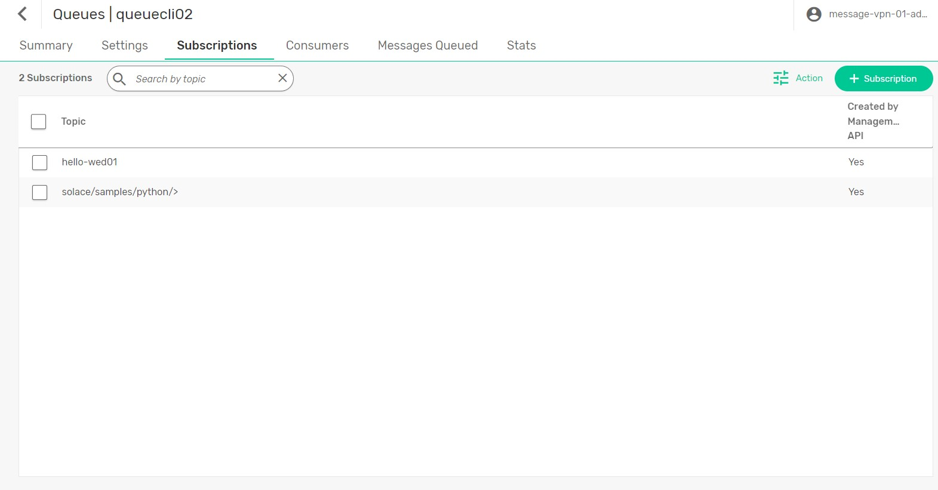

Publishing messages to the topic solace/samples/python/persistent/pub

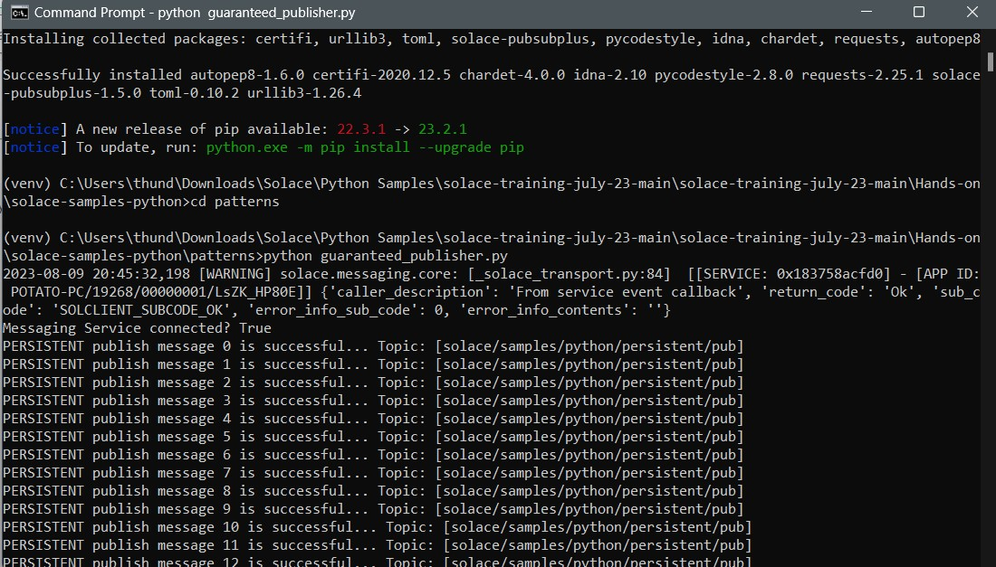

Here, We can see the messages received

